Student Declaration

To whom so ever it may concern
This is to declare that this report has been written by Mahesh Kumar Pradhan, Sahib Singh, Parmeshwar kumar sahu. No part of the report is copied from other sources. All information included from other sources have been duly acknowledged. I/We ever that if any part of the report is found to be copied, I/we are shall take full responsibility
for it.



Mahesh Kumar Pradhan: (11904325) ,roll no. :(32)
Sahib Singh: (12008326) ,roll no. :(36)
Parmeshwar kumar sahu:(11917629 ,roll no. :(42)
Dated: 31 October ,2020

Technologies and Framework to be used
- Python is a widely used general-purpose, high level programming language. It was created by Guido van Rossum in 1991 and further developed by the Python Software Foundation. It was designed with an emphasis on code readability, and its syntax allows programmers to express their concepts in fewer lines of code.
- Python is a programming language that lets you work quickly and integrate systems more efficiently.
- Python offers multiple options for developing GUI (Graphical User Interface). Out of all the GUI methods, tkinter is most commonly used method. It is a standard Python interface to the Tk GUI toolkit shipped with Python. Python with tkinter outputs the fastest and easiest way to create the GUI applications. Creating a GUI using tkinter is an easy task.

To create a tkinter :
- Importing the module – tkinter
- Create the main window (container)
- Add any number of widgets to the main window
- Apply the event Trigger on the widgets.

Let’s see how to create a IPL scoreboard using Python GUI library Tkiner. The Scoreboard will be able to give live IPL score updates with just one button. It will show scoreboard of both teams along with Overs

INTRODUCTION OF THE PROJECT

Objectives and Motivation:
We are given GUI based python project , we choose live update IPL score board as we three are very much passionate for Cricket and so do millions of other people are. Majority of them would be youngster. In addition to it, it is IPL season. Newspapers – TV news are filled with cricket news. People barely have to time to see whole match. Moreover, it is paid as well. So people who doesn’t have subscription of Live Broadcasting the prefer to watch live scoreboard and this is what fascinated us to make this project as we are fond of IPL so why not work something we love doing.

Python Project on Online Cricket Score Board:

Aim:This application can be used by the organization to manage cricket sport effectively. Organization requires good application to update the score board as the game progress. This application serves the same purpose. Display board screen will take care ball to ball update instantly and it will update all the other details.

Source code:
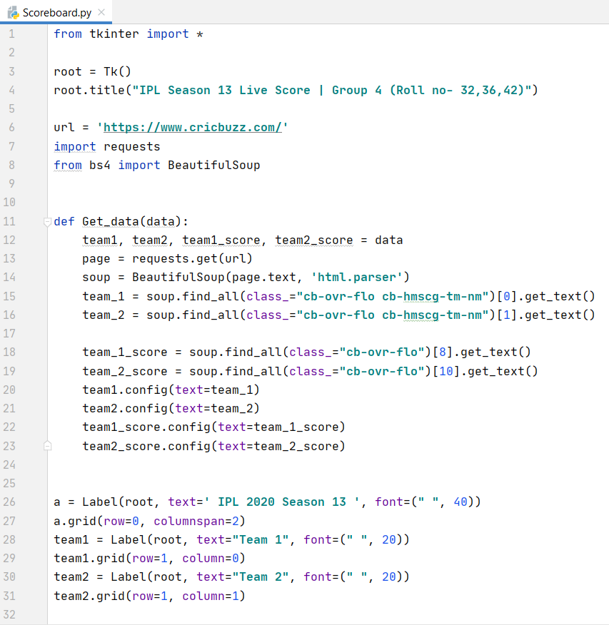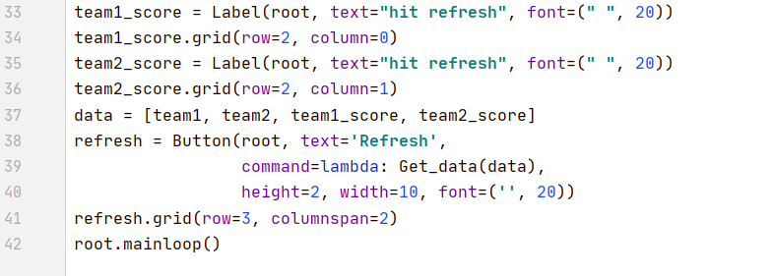

➢ Output and Background of the project:

With the help of this IPL Score board, live score can be seen with the help of just one refresh button.

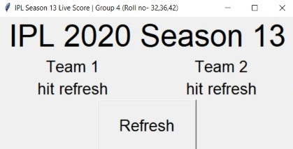
Press refresh button to update score

- This is normal output shown when the code is first implemented. A window gets popped, with a title”IPL Season 13 Live Score”. Just below the title, in the main window heading appears ”IPL 2020 Season 13 ”. As we can see two teams displayed right in the centre as “Team 1” and “Team 2”. The main part of the window is the “Refresh” button. Hit the the refresh button and the output will be show.

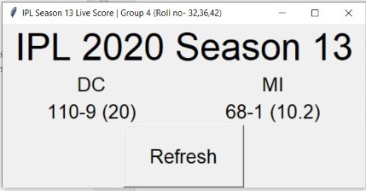
As DC vs MI match is going on. This show Live score
e score

- After pressing the “Refresh” button, A new output is produced. The whole window will be same, but the changes would in place of “Team1” and “Team 2” , the team names would be shown with their score,

Note: Every time you hit on “REFRESH” button, the updated score is shown.

ER MODEL OF IPL LIVE SCOREBOARD

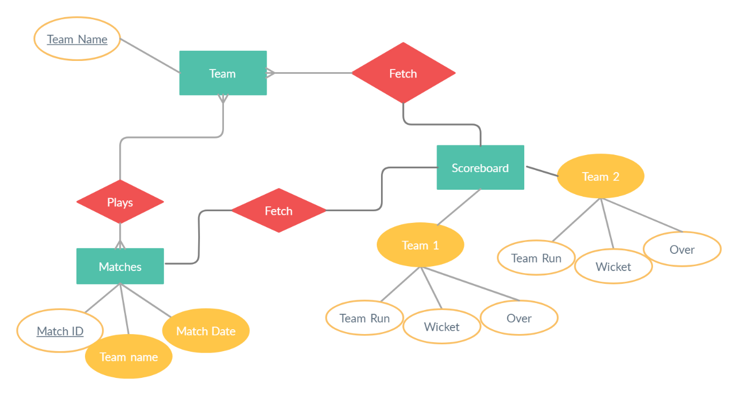

DFD of IPL LIVE SCOREBOARD
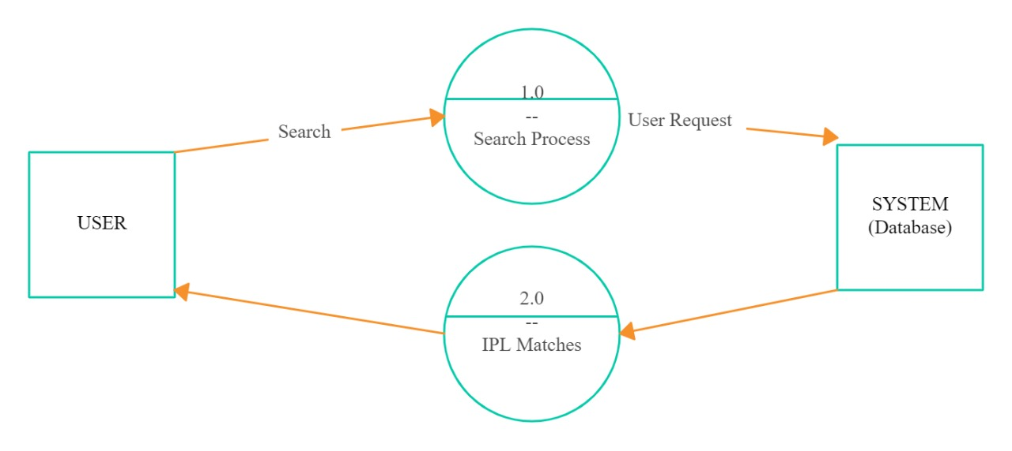METHODOLGY:

GUI and Functions used:

- Tkinter
- Get_data
- Import Request
- Beautiful Soup

